

**Estimating the Announcement Effect of the Volcker Rule**

DSC 5101 ANALYTICS IN MANAGERIAL ECONOMICS

Group Project 2

WANG XINRUI (Student ID: A0186103M, Email: xinrui.wang@u.nus.edu)

REN JIEWEN (Student ID: A0186102N, Email: jiewen.ren@u.nus.edu)

ZHANG AO (Student ID: A0176595L, Email: e0232199@u.nus.edu)

LI LIPING (Student ID: A0186040M, Email: liping.li@u.nus.edu)

1. Executive Summary

**1.1 Background**

The ***Volcker Rule (VR)*** is one of the core elements of the Dodd-Frank Act. It prohibits banks from conducting certain investment activities with their own accounts, for example, short-term proprietary trading of securities, [derivatives](https://www.investopedia.com/terms/d/derivative.asp) and commodity futures, as well as options on instruments that regard as conflicts of interest with banks’ clients. It aims to protect customers by preventing those types of speculative investments that contributed to the 2008 financial crisis. VR intended to be implemented on July 21, 2010, but it actually came into effect on July 21, 2015. This paper will investigate whether the Volcker Rule had an announcement effect on banks’ business models and risk-taking in quarters between the Q3 2010 and the Q2 2015. Through this report, we will construct a baseline framework, perform propensity matching, conduct risk test to inspect the effectiveness of VR and the difference in magnitude across different banks.

**1.2 Structure**

Section 2 introduces our baseline model using ***Trading asset ratio (TAR)*** as the dependent variable and discusses some different forms **including and excluding** **control variables** and **fixed effects** into account. Section 3 demonstrates the **propensity score match** methodology to scale down sample bias problem. Section 4 and 5 shows other robustness tests on the baseline model. Section 6 conducts the **Placebo Test** in which we randomly assigning bank holding companies into **Control and Treatment groups**. In Section 7, we also examine an additional hypothesis about the banks’ overall risk-taking measured by **Z score**, to understand if banks have fundamentally reduced their risk.

**1.3 Key findings**

* From the baseline model, banks tend to reduce their **TAR** after the announcement of the Volcker Rule. From this perspective, we would say the rule is generally effective in preventing banks from risky investments. On average, there is **0.099%** in trading assets ratio **decrease** across banking industry.
* The decrease is also statistically significant. In particular, those **affected BHCs** with trading asset ratio higher than 3% have reduced their TAR by **2.33%** compared with **non-affected BHCs**.
* VR has a strong effect on the **top 30 banks** with the highest average TAR before 2007. They have reduced TAR by approx. **6.33%** **more** than non-treated banks after theannouncement.
* Focusing on the **overall risk target** of banks measured by **Z score**. On the contrary, there is **no decreasing tendency** in the risk-taking behavior of banks after the announcement of VR, or even it shows a tendency to increase.

**1.4 Recommendations**

* The robustness tests show evidence that banks began to reduce their trading assets in response to the VR. However, the results do not imply lower overall risk-taking levels. VR is effective on TAR reduction, especially for top 30 group with high TAR portfolio.
* For **banks**, our study reveals banks have shifted proprietary trading to other **excepted speculative investments**. This will potentially diminish and negate the effectiveness of VR if the reduction of banks’ overall risk was the essential target.
* For long term planning, **regulators** should keep in mind that those affected BHCs might transform their business strategies by investing in other lower risk revenue generators to buffer the effect. Regulators might want to **analyze the unintended consequences** of the Volcker Rule in more detail, especially since its implementation might cause a drop in affected banks’ earnings.

2. Baseline Model

In order to test the effect of the Volcker Rule, we start from a simple model to evaluate the changes in the trading asset ratio. Variable definitions are provided in *Appendix 1*. If all the variables are included in the model, it may face the endogeneity problem, thus several forms of the baseline model are designed. Assume that BHCs with large trading books which are now banned or limited by the Volcker Rule, will be affected the most and show the strongest reactions. The baseline formula is given below, refer to *Appendix 3* for detailed explanation of the model.

$$Y_{i,t}=α_{0}+β_{1}∙After {DFA}_{t}+β_{2}∙{Affect}_{i}+β_{3}∙\left(After {DFA}_{t}*{Affect}_{i}\right)+γ_{i}+δ_{t}+X_{i,t}+ε_{i,t}$$

|  |  |  |  |  |
| --- | --- | --- | --- | --- |
| **Baseline Test Results** | | | | |
|  | **1** | **2** | **3** | **4** |
| **Dependent Variable** | **Trading asset ratio** | | | |
| **after_DFA** | 0.0005076 * | -9.917e-04 *** | 0.000045 |  |
| (0.0002004) | (2.109e-04) | (1.614e-04) |  |
| **Affected_BHC** |  |  | 0.100000 *** |  |
|  |  | (0.0007367) |  |
| **after_DFA : Affected_BHC** |  |  | 0.003682 *** | -0.023327 *** |
|  |  | 0.001072 | 0.000528 |
| **Controls** | NO | YES | YES | YES |
| **FE** | NO | NO | NO | YES |
| **R-squared** | 0.0001549 | 0.234 | 0.5555 | 0.053135 |

*Table 2.1*

*Standard errors are clustered at the BHC level and reported in parentheses; significance levels indicated by *** p < 0.01, ** p < 0.05, * p < 0.1.*

The table above shows the results of four variations of the baseline model. The coefficient of the interaction term in the last model is negative and significant, which means the affected banks started to reduce their trading asset ratios by **2.33%** after the announcement of the Volcker Rule.

3. Robustness Test: Propensity Score Match

##### We use **Propensity Score Match (PSM)** to strengthen causal arguments by matching with one or more control cases based on each case’s propensity score to reduce selection bias. We matched one treated bank with three control bank (1:3) for Q3 2004, followed by a matching ratio of 1:5 for Q3 2004 (same quarter of the same year), and a matching ratio of 1:3 for Q2 2009. Based on *Appendix 5.2.1*, before matching, the treated banks were on average have more total assets and a higher leverage ratio, had lower deposit ratio and real estate ratio than control schools. After matching, the **treated and control banks** after matching are very **similar** now in terms of Total Asset, Credit Risk Ratio, Deposit Ratio, Real Estate Ratio, and Liquidity Ratio. Detailed procedures of PSM can be found in *Appendix 3.*

|  |  |  |  |  |
| --- | --- | --- | --- | --- |
| **Robustness Test: Propensity Score Match** | | | | |
|  | **1** | **2** | **3** | **4** |
| **Dataset choice** | **Full dataset** | **Q3 2014 with 1:3** | **Q3 2014 with 1:5** | **Q2 2009 with 1:3** |
| **Affected_BHC : after_DFA** | -0.0233 *** | -0.0275 *** | -0.0282 *** | -0.0212 *** |
| (0.000528) | (0.00219) | (0.00171) | (0.00166) |
| **Controls / FE** | YES | YES | YES | YES |
| **Num. of Observations** | 40026 | 1652 | 2671 | 2172 |
| **R-squared** | 0.053135 | 0.19166 | 0.15188 | 0.10396 |

*Table 3.1*

According to *Table 3.1*, all PSM models produce **significant result**s, and the **coefficient values** are **similar** to the **baseline model,** indicating that the affected banks started to reduce their trading asset ratios after the announcement of the VR and our results were robust.

# **4. Other Robustness Tests: group effects and other specifications**

**4.1 Top 30 Trading Asset Ratios Analysis**

Majority of the BHCs already had a low or even zero TAR when the VR was introduced. Therefore, we decided to inspect whether the BHCs with higher trading asset ratios reacted stronger to the introduction of the VR. We divided the Matched dataset (Q3 2004 with 1:3) into 3 groups. Group 1 contained the top 30 banks with the highest trading asset ratios before the VR, with the rest being other treatment (not top 30) and control groups. Refer to *Appendix 10* for the plot of TAR in three different groups*.* Results show that the **top 30 banks** **responded** VR **more significantly** to by reducing their trading asset ratio by **2.91% more** than non-treated banks and 1.23% more than other treated bank (not top 30). This might be because that banks with higher TAR needed more effort to meet with the new regulation.

**4.2 Bottom 30 Trading Asset Ratios Analysis**

A similar analysis on the **Lowest 30 banks** shows that the 30 banks with the lowest (but > 0) TAR before the VR **reduced their assets by 3.10%** compared to the average of 2.33%. Refer to *Appendix 7* for detailed results.

**4.3 Exclude non-trading-BHCs analysis**

In addition, we tested the robustness of our model when **excluding all entities that have zero trading banks**. We conclude that banks that were trading before the announcement of VR **reduced their assets by 2%** compared to the average of 2.33%. Refer to *Appendix 8* for detailed results.

**4.4 Pre-2007 affectedness analysis**

The above analyses have defined the affectedness of a BHC by the Volcker Rule, by its average trading asset ratio during the pre-DFA period. However, this might be endogenous, as banks might have changed their business models during the financial crisis. In order to deal with this, we decided to use the **average trading asset ratio over the 15 quarters before 2007**. We find that BHCs **reduced their assets by 0.67%** using this pre-2007 ratio as an identifier compared to the average of 2.33%. Refer to *Appendix 9* for detailed results.

|  |  |  |  |  |  |
| --- | --- | --- | --- | --- | --- |
| **Other Robustness Test** | | | | | |
|  | **1** | **2** | **3** | **4** | **5** |
| **Dependent Variable** | **Treatment dummy** | **Top 30** | **Bottom 30** | **Exclude non-trading-BHCs** | **Pre-2007 affectedness** |
| **Affected_BHC:Affect** | -0.0233 *** | 0.06333 *** | -0.02787 *** | -0.03124 *** | -0.00676 *** |
| **Controls / FE** | YES | YES | YES | YES | YES |
| **R-squared** | 0.053135 | 0.2236 | 0.1986 | 0.20073 | 0.3128 |

*Table 4.1*

Overall, from table 3.1 and 4.1, we conclude that the **baseline model** is **relatively robust** under various specifications - propensity score matching approach, different groupings, alternative affectedness definitions.

**5. Placebo Test**

The placebo test inspects whether the the introduction of the VR attributes to reduction in trading asset ratio. In this part, we **randomly assigned** the treatment and control labels**(1 or 0**) to the **BHCs data** (Affected_BHC) from the first quarter of 2007 to second quarter of 2009 (before the announcement of the Volcker Rule), and ran the model for **100 times**.

# *Figure 5.1* shows the distribution of placebo estimates. The reduction in trading asset ratio from our baseline model is around 2.33% while the placebo results are very closely centered to **0%**, and it is **significantly different** from the baseline model result. This approach conﬁrms that the affected banks have signiﬁcantly decreased their trading asset ratios after the announcement of the VR.

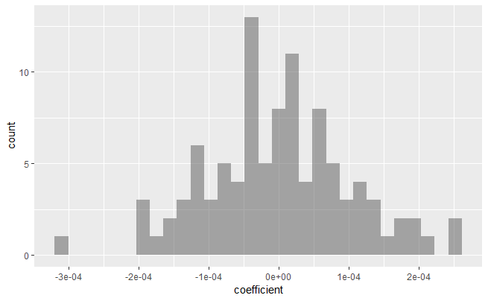

*Figure 5.1*

# **6. Additional Hypothesis**

**6.1 Overall risk measurement**

We can measure the overall effectiveness by investigating the banks’ risk-taking behaviors before and after the enactment of the Volcker Rule. Then we give the hypothesis that the rule is effective as follows:

H0: Affected banks had a lower overall risk after the announcement of the Volcker Rule.

A normalized Z-score is calculated as measurement based on Returns of Assets (RoA) and Capital Asset Ratio (CAR). In our dataset, CAR is Leverage ratio, the formula is given as below:

$$Z score=\frac{RoA+Leverage ratio}{σ(RoA)}$$

$σ(RoA)$ captures asset return volatility. The calculation method results in a low-risk bank will have a high value of Z-score. In this report, we adopt a natural logarithmic transformation to solve skewness of the data. The model is:

$${log⁡(z score)}_{i,t}=α_{0}+β_{1}∙After {DFA}_{t}+β_{2}∙{Affect}_{i}+β_{3}∙\left(After {DFA}_{t}*{Affect}_{i}\right)+γ_{i}+δ_{t}+X_{i,t}+ε_{i,t}$$

We plot the change in of three different groups from Q3 2004 to Q2 2005. Refer to *Appendix 11* for the figure.

* **Z-score calculation:** using the formula for z score, $σRoA$ is computed from 7 quarters and based on at least 3 observations. Applying the moving window approach, we can take the fixed effect of time periods into account.

**6.2 Model Results**

We construct a panel data regression model using the z-score as dependent variable to analyze. The result is shown in *Appendix 12.*

First, we note that the coefficient on the ‘after DFA’ indicator is positive and statistically significant. This indicates BHCs have reduced their risk of default significantly after the announcement of the rule. Also, we focus on the coefficient of the interaction term, the coefficient is positive but not significant. Therefore, we reject $H_{0}$ based on p-values at **0.1066**, which means the treatment group does not reduce their overall risk more strongly as compared to unaffected banks. Hence, there is not enough evidence we can say the effect on affected BHCs is larger.

# **Bibliography**

### Acharya, V. V., Cooley, T. F., Richardson, M. P., Walter, I., et al. (2010). Regulating Wall Street: The Dodd-Frank Act and the New Architecture of Global Finance. Wiley.

### Chung, S., Keppo, J., and Yuan X. (2015). “The impact of Volcker Rule on bank profits and default probabilities.” Working paper, available at SSRN: http://ssrn.com/abstract=2167773.

### “Difference‐in‐Differences Estimation”, Imbens/Wooldridge, Lecture Notes 10, summer 2007. <http://www.nber.org/WNE/lect_10_diffindiffs.pdf>

### Introduction to econometrics, James H. Stock, Mark W. Watson. 2nd ed., Boston: Pearson Addison Wesley, 2007.

### Keppo, Jussi, and Josef Korte. “Risk Targeting and Policy Illusions - Evidence from the Announcement of the Volcker Rule .” *Management Science*, no. 64, 2018, pp. 215–234.

### “Lecture 3: Differences‐in‐Differences”, Fabian Waldinger <http://www2.warwick.ac.uk/fac/soc/economics/staff/ffwaldinger/tea>ching/ec9a8/slides/lecture_3_‐_did.pdf

### Randolph, Justus J, et al. “A Step-by-Step Guide to Propensity Score Matching in R.” *Practical Assessment, Research & Evaluation*, vol. 19, no. 18, Nov. 2014.

**Appendix**

### Appendix 1: Variable definitions

### Appendix 1.1: Dependent variables

|  |  |
| --- | --- |
| **Trading asset ratio** | Ratio of trading assets to total assets |
| **z-score** | Ratio of trading assets to total assets |
| **Return on assets, RoA** | Natural logarithm of ratio of net operating income to average total assets |

Appendix 1.2: Explanatory variables and controls

|  |  |
| --- | --- |
| **id** | Banking holding company code |
| **Time** | Time |
| **Affected BHC** | Dummy variable takes a value of one if the average trading asset ratio during the pre-DFA period (Q3 2004 - Q2 2009) was equal to or larger than 3%, and zero otherwise. |
| **After DFA** | Dummy variable that equals one for all quarters between the third quarter of 2010 and the second quarter of 2015, and zero for all quarters from the third quarter of 2004 to the second quarter of 2009 |
| **Leverage ratio** | Average equity divided by average total assets |
| **Total assets** | Natural logarithm of total assets |
| **Credit Risk Ratio** | Non-performing loan ratio, past due and nonaccrual loans divided by total loans |
| **Cost-income ratio** | Operating expenses divided by total in- come |
| **Deposit ratio** | Average deposits divided by average total assets |
| **Real estate loan ratio** | Loans secured by real estate divided by total loans |
| **CPP** | Capital Purchase Program indicator variable takes one if the bank is a current recipient of CPP funds in a given quarter, and zero otherwise |
| **Liquidity ratio** | Natural logarithm of ratio of cash and balances at other depository institutions to average total assets |

### Appendix 2: Summary of Statistics

The following table reports variable names, means, standard deviations, minimum and maximum values, and the number of observations for the main variables of the dataset. The data sources are: FED Chicago BHC database (BHC), Credit Suisse Hedge Fund Index (CS), Thomson Reuters Datastream (DS), U.S. Department of the Treasury (TR). The dataset covers the time period from Q3 2004 to Q2 2015. We compute some extra variables including *ln_z_score* and *asset return volatility* and conduct the descriptive statistics on the combined dataset.

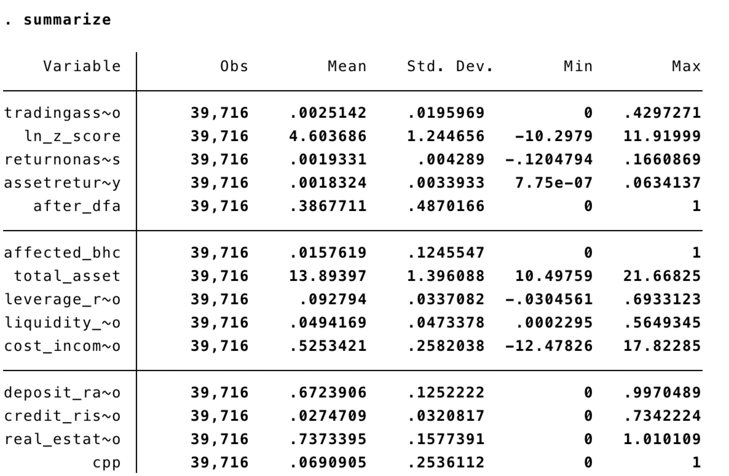

# Appendix 3: Difference-in-Differences fixed effect model

# $β_{i}$ is the coefficient of interest measuring the announcement effect of the Volcker Rule.

# $Y_{i,t}$ and $δ_{t}$ are bank holding company fixed effect and time fixed effect respectively, which are used to control for influences constant either over time or across BHCs.

# $X_{i,t}$ include control variables to test for additional covariates that might vary over both time and bank and that might influence banks’ business models.

$$Y_{i,t}=α_{0}+β_{1}∙After {DFA}_{t}+β_{2}∙{Affect}_{i}+β_{3}∙\left(After {DFA}_{t}*{Affect}_{i}\right)+γ_{i}+δ_{t}+X_{i,t}+ε_{i,t}$$

# Appendix 4: Baseline model - DiD Regression with Fixed Effects and Controls

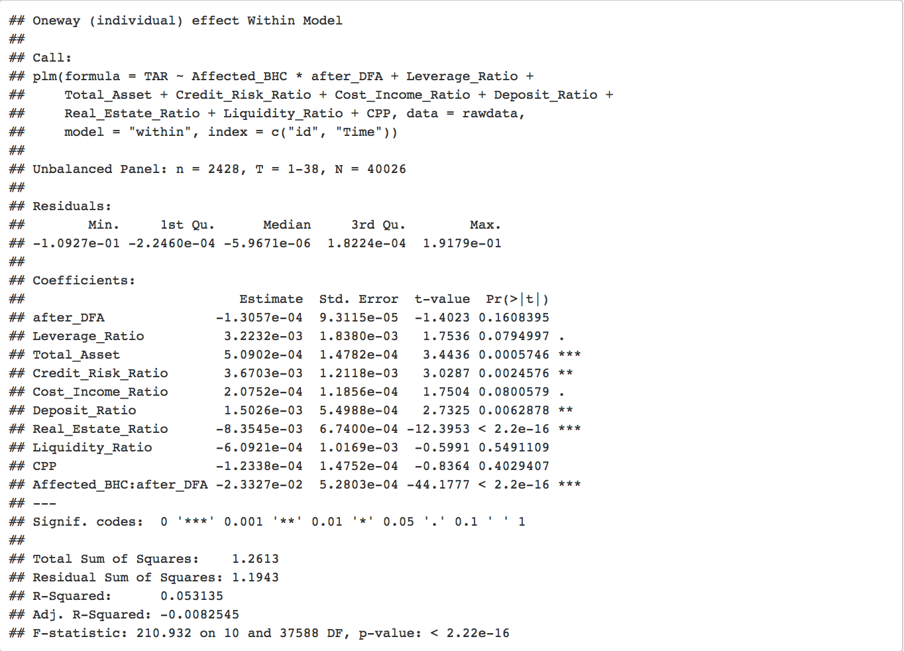

# Appendix 5

# 5.1: Detailed procedures of Propensity Score Match

##### For Propensity Matching:

##### Step 1:We first use logistic regression: dependent variable(propensity score) is Affected BHC,independent variables are the control variables for each bank’s forecast.

##### Step 2:We use a 1:3/1:5 nearest neighbor matching without replacement to match each affected BHC with a BHC that is not affected but has the closest propensity score.

##### Step 3: We run our model on the matched sample that should only contain banks that are very similar in their propensity to be affected, with half of them being affected and half of them not. Although this matching exercise strongly decreases our sample size, we find a coefficient of similar economic and statistical significance.

### 5.2.1: Before and after propensity score match for Q3 2004 with a matching ratio of 1:3

The rightmost columns in these summary data show the median, mean, and maximum quartile-differences between the treated and control data; smaller QQ values indicates better matching. It is clear that propensity score matching is a useful tool for reducing selection bias and strengthening causal conclusions.

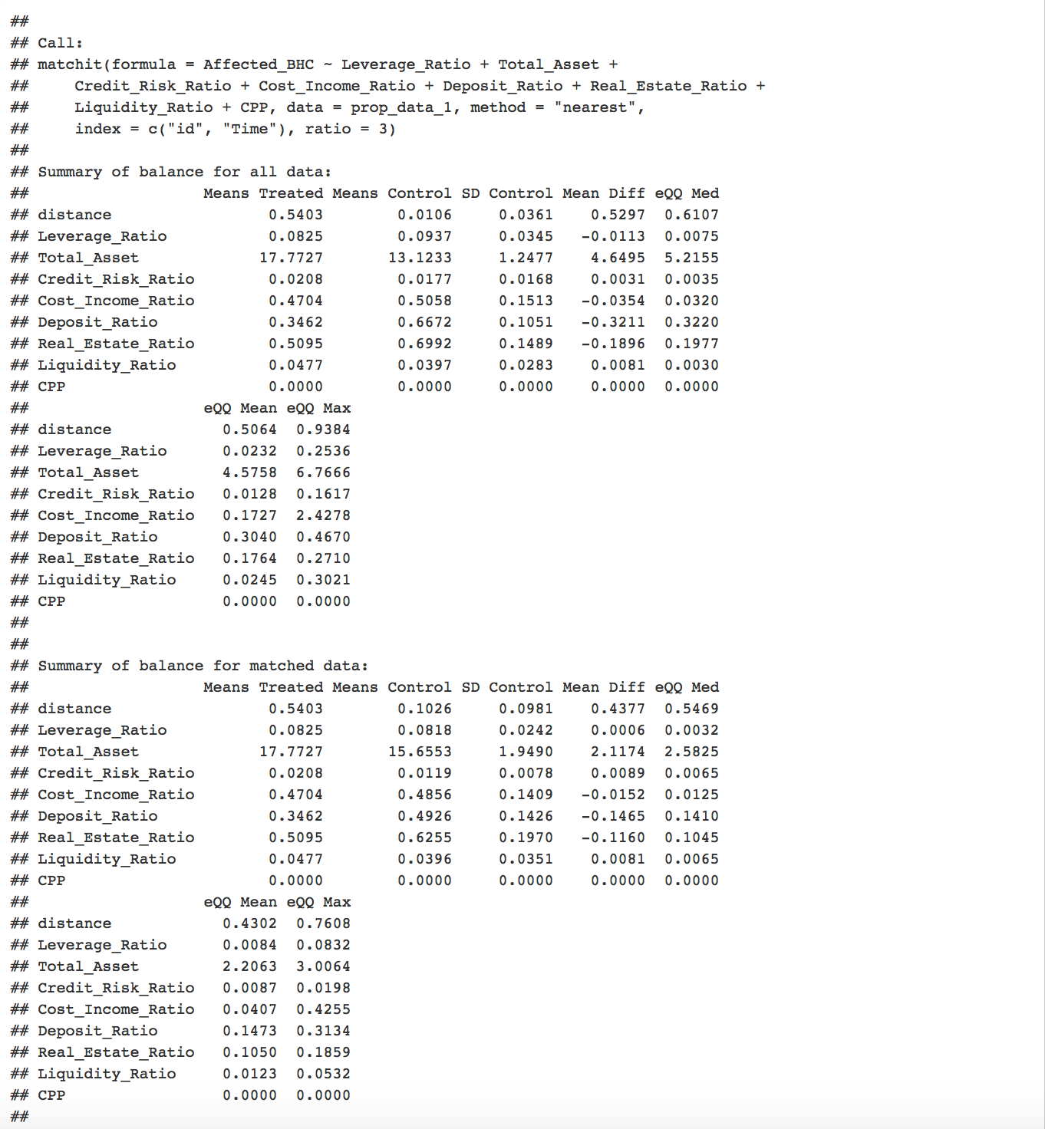

### 5.2.2: Propensity Score Match for Q3 2004 with a matching ratio of 1:3

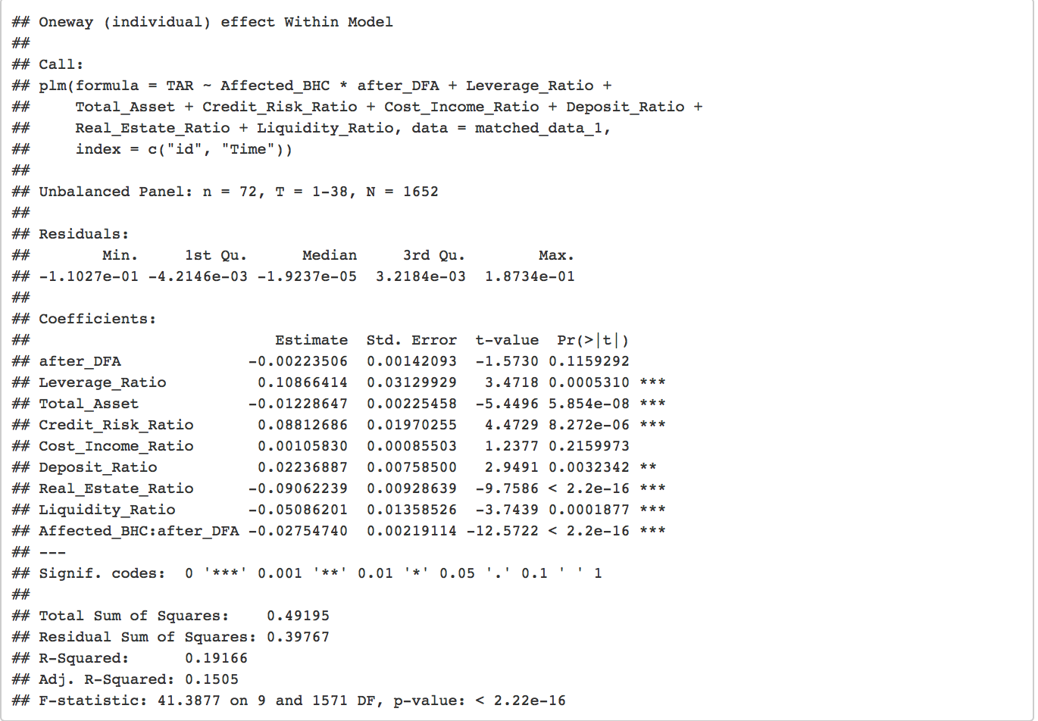

### 5.3: Propensity Score Match for Q3 2004 with a matching ratio of 1:5

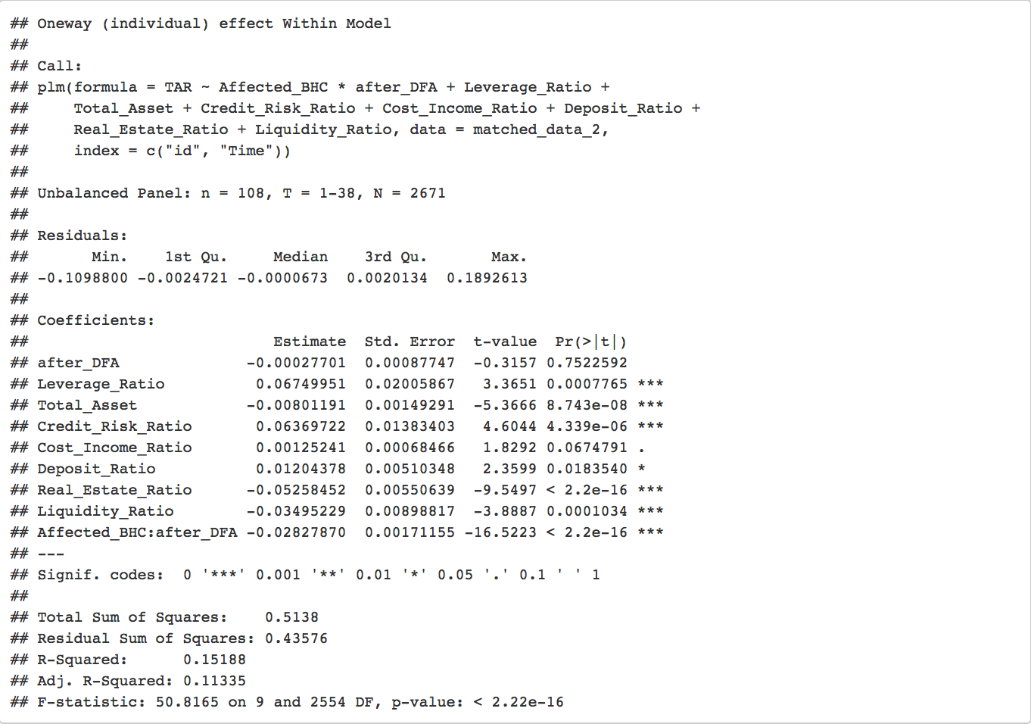

### 5.4: Propensity Score Match for Q2 2009 with a matching ratio of 1:3

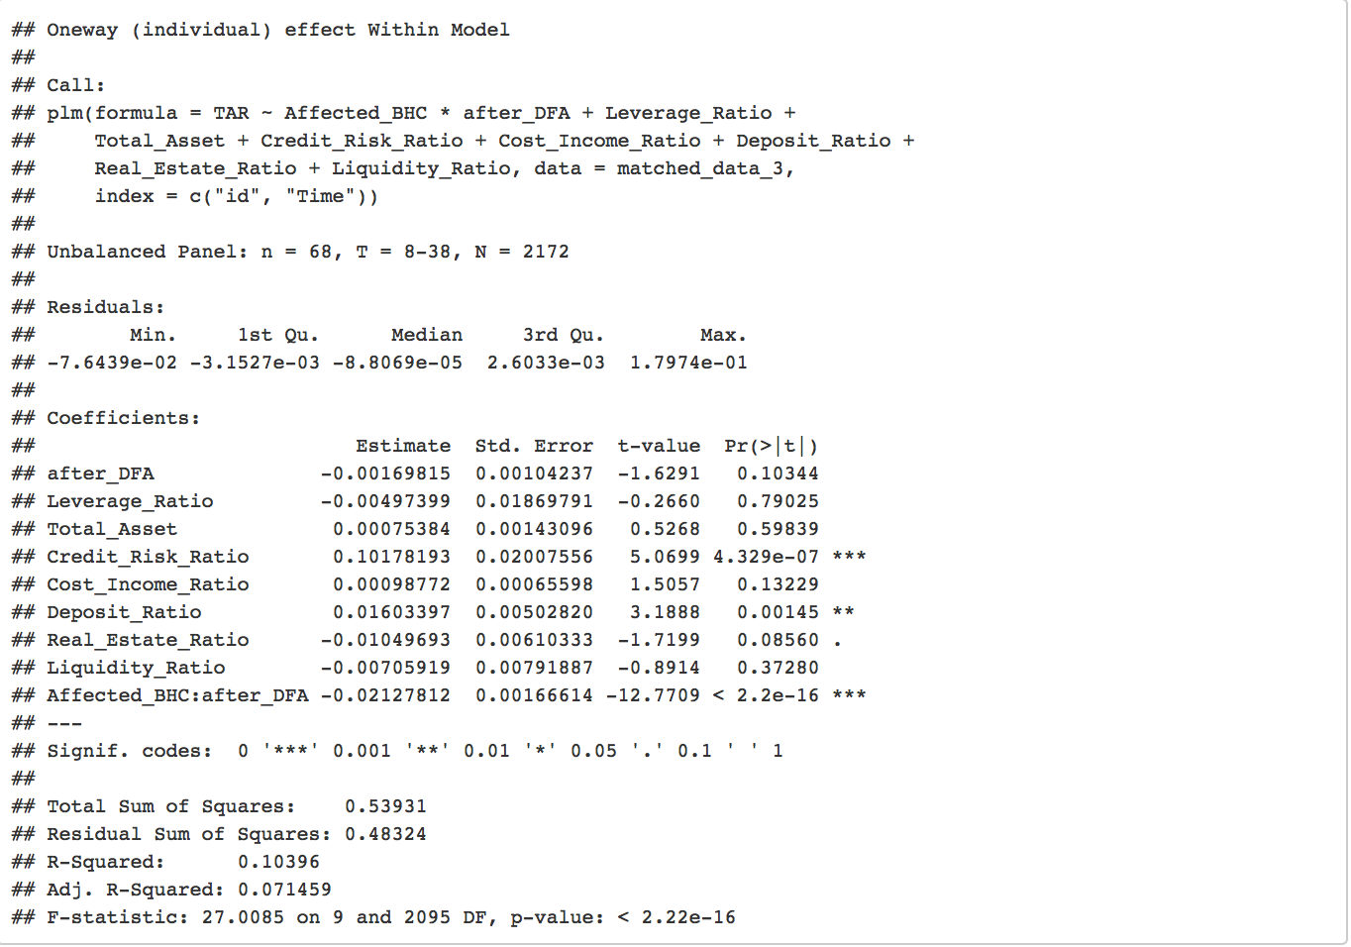

### Appendix 6: Top 30 Trading Asset Ratios Analysis

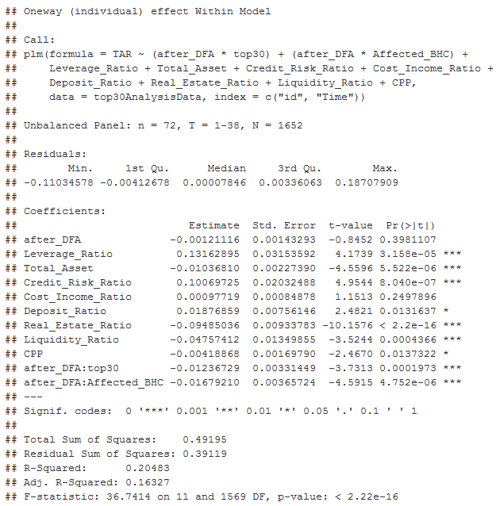

### Appendix 7: Bottom 30 Trading Asset Ratios Analysis

### 

### 

### 

### 

### 

### 

### Appendix 8: Exclude non-trading-BHCs analysis

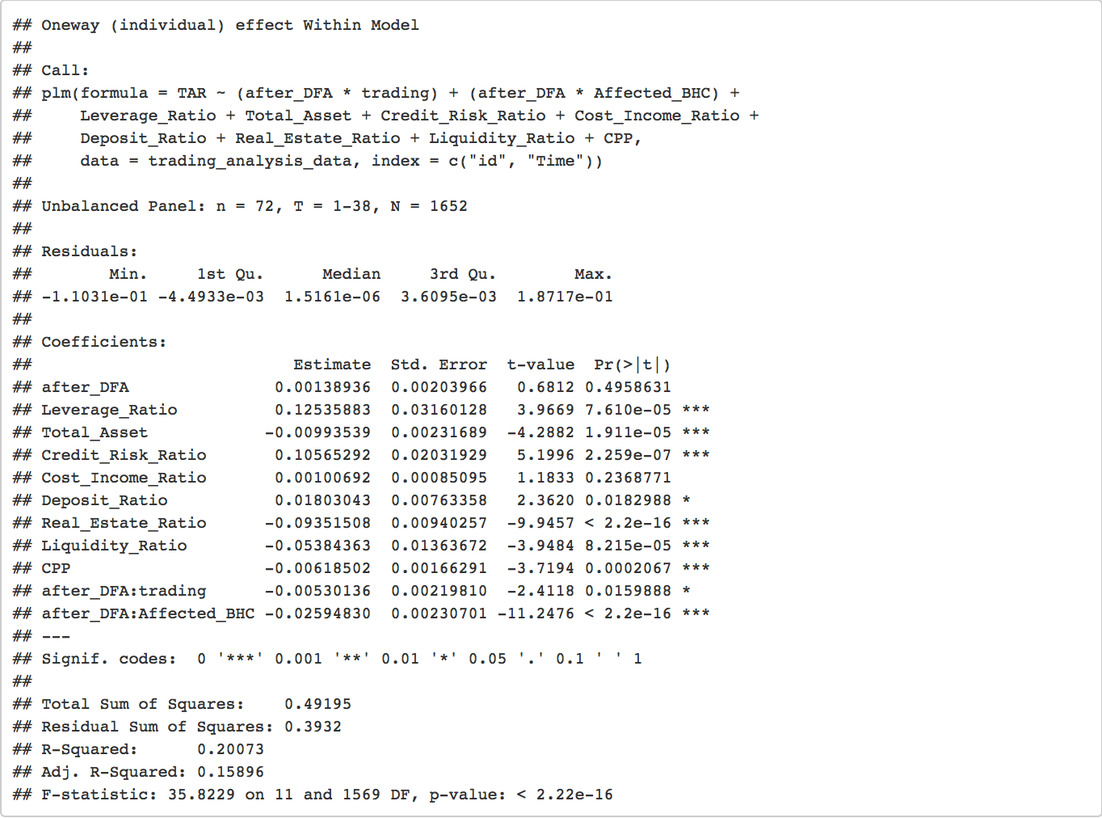

### 

### 

### Appendix 9: Pre-2007 affectedness analysis

'After DFA' is one for the quarters Q3 2010 – Q2 2015 and zero for the quarters Q3 2004 – Q2 2009.

'Affect (pre_2007_TAR)' is the average trading asset ratio in the 15 quarters previous to 2007 (Q2 2003 – Q4 2006).

Control variables comprise total assets, leverage ratio, liquidity ratio, deposit ratio, credit risk ratio, real_estate ratio, cost-income ratio, and quarter and BHC fixed effects are included in the models as indicated.

### 

### 

### Appendix 10: Trading asset ratios in three different groups

The graph shows the average trading asset ratio of the 30 bank holding companies with the highest trading assets ratio in the 15 quarters before 2007. In these quarters, banks went along their own business model and there was not administrative influence before the financial crisis in 2008. We regard banks with an average transaction asset ratio greater than 3% as the treatment group. Banks with an average trading asset ratio of non-zero but below 3% and closest to the treatment group's banks are in the control group.

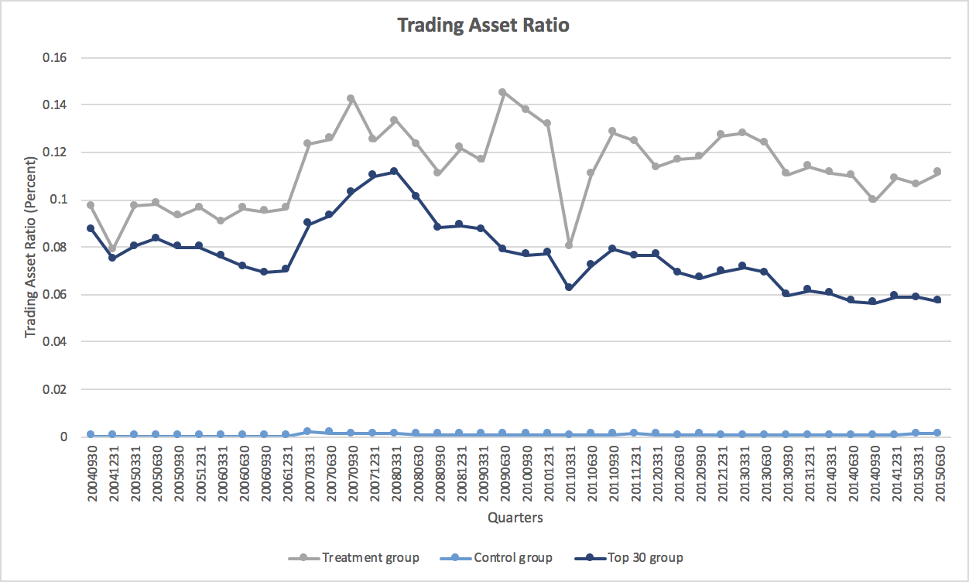

### Appendix 11: Overall risk-taking in three different groups

This figure shows the average quarterly z-score in natural logarithm of the banks in the top 30 group, treatment group, and control group separately. The top 30 group consists of BHCs with the highest average trading asset ratio during Q3 2004 – Q2 2009, and banks with an average trading asset ratio greater than 3% during the same period are in the treatment group. Banks with a non-zero average trading asset ratio but less than 3% and the closest propensity score with the banks in the treatment group are in the control group. Because we omit infinite values of z score, the data in some quarters is not available. The dotted line represents an imagined tendency of ‘ln_z_score’ in the top 30 group.

### 

### 

### Appendix 12: Overall risk-taking analysis

The assumption underpinned z-score is that a bank becomes insolvent when its capital level falls to zero. Z score is a composite measure for BHCs' risk, the higher a bank's z score is, the less likely it defaults. After calculating z score for each quarter, the result is based on data omitting rows with infinite z score values. The interaction term investigates whether this effect varies by the likely affectedness of a bank by the VR.

